
“ XON1X ”
A Semester Project in C++ DSA

Presented By.

Muhmmad Immad (23i-0026)
Sardar Muneeb ur Rehman (23i-6076)

Table of Contents

1. Title Page…………………………………………………… 1
2. Team and Contribution……………………………………. 3
3. Introduction………………………………………………… 4
4. Main Menu…………………………………………………. 4/5
4.1 Overview
4.2 Implementation Details
4.3 Techniques and Compliance
5. Login, Registration, and Authentication…………………. 5/6
5.1 Overview
5.2 Implementation Details
5.3 Techniques and Compliance
6. Top Players Board (Leaderboard)………………………… 6/7
6.1 Overview
6.2 Implementation Details
6.3 Techniques and Compliance
7. Inventory System (Themes)………………………………... 7/8
7.1 Overview
7.2 Implementation Details
7.3 Techniques and Compliance
8. Single-Player Mode (Adventure Mode)…………………… 8/9
8.1 Overview
8.2 Implementation Details
8.3 Techniques and Compliance
9. Multiplayer Mode…………………………………………... 9/10
9.1 Overview
9.2 Implementation Details
9.3 Techniques and Compliance
10. Friend System and Matchmaking Queue……………..… 10/11
11. Player Profiles and Save Game Feature…………………. 11
12. Conclusion / Attachments………………………………… 12/13/14

Logistics:

Project Report
Submitted by:
Muhammad Immad: 23i-0026
Sardar Munneb : 23i-6076
Submitted to: Sir Zahoor Hassan
Data Structures and Algorithms
Submission: May 13, 2025
Group#50

Team and Contribution:
Our team includes two members, each playing a key role in the project,
• Muhammad Immad (Backend Development)
-> Handled core game logic for both single-player and multiplayer modes.
-> Built custom data structures (Min-Heap, AVL Tree, array-based stack) as STL usage was restricted.
-> Implemented file handling for login, leaderboard, and themes.
-> Ensured all work aligned with project rules (no STL, only custom structures).
• Sardar Munneb (Frontend Development)
-> Designed the graphical interface using SFML: main menu, login screen, and in-game visuals.
-> Added background images and sound effects for a better experience.
-> Created pause and win menus for smoother interaction.
-> Connected frontend with backend logic seamlessly.

Introduction:
This C++ game uses SFML and follows strict project rules. Features include a main menu, user login, leaderboard, inventory (themes), game modes (single and multiplayer), matchmaking, profiles, and save game support. All structures (Min-Heap, AVL Tree, linked lists, hash tables) are made from scratch. Libraries like <vector> and <algorithm> are avoided.
The report explains each part—from user interface to core features, then game modes and extras—highlighting how restrictions were met and improvements added (e.g., sound, visuals, pause menu).

Main Menu:

Overview
The main menu, in MainMenu.cpp, is the central navigation hub, offering Play, Options, Instructions, and Exit, using SFML graphics.

Implementation Details
• Graphical Interface: Uses sf::Text for displaying options with a custom font and a background image.
• Navigation: Arrow keys move through options with sounds for navigation and selection.
• Theme Integration: loadThemeFromFile applies selected themes using data from an AVL Tree.
• Code Example:
void MainMenu::handleInput(sf::RenderWindow& window) {
sf::Event event;
while (window.pollEvent(event)) {
if (event.type == sf::Event::KeyPressed) {
if (event.key.code == sf::Keyboard::Up) {
navigateSound.play();
moveUp();
} else if (event.key.code == sf::Keyboard::Down) {
navigateSound.play();
moveDown();
} else if (event.key.code == sf::Keyboard::Enter) {
selectSound.play();
// Handle selection
}
}
}
}

Techniques and Compliance
• Modular MainMenu class with separate input and movement functions.
• Menu items in a fixed-size array—no STL used.
• Background music and sounds enhance gameplay.
• Theme preferences saved via file handling.

Login, Registration, and Authentication:

Overview
Implemented in LoginWindow.cpp/.h, users can register, log in, and access the game. Credentials are stored in users.txt.

Implementation Details

• UI: Built with sf::Text and background visuals. Input handled via keyboard.
• Authentication: Checks credentials against stored data in users.txt.
• Registration: Validates new users, prevents duplicates, and saves new data.
• Code Example:
bool LoginWindow::authenticate(const std::string& username, const std::string& password) {
std::ifstream file("users.txt");
std::string line;
while (std::getline(file, line)) {
size_t pos1 = line.find(':');
size_t pos2 = line.find(':', pos1 + 1);
std::string storedUsername = line.substr(0, pos1);
std::string storedPassword = line.substr(pos1 + 1, pos2 - pos1 - 1);
if (storedUsername == username && storedPassword == password) {
file.close();
return true;
}
}
file.close();
return false;
}
Techniques and Compliance
• Uses <fstream> for file access.
• Passwords checked for length and uniqueness.
• Uses <string> only—no disallowed libraries.
• Basic input and error handling included.

Leaderboard:

Overview
The leaderboard shows top 10 players by score. It’s part of LoginWindow.h and used in MainMenu.cpp.

Implementation Details
• Data Structure: Custom MinHeap holds username and score.
• File Integration: Loads scores from users.txt.
• Display: Renders sorted scores via sf::Text.
• Code Example:
class MinHeap {
private:
struct PlayerScore {
std::string username;
int score;
};
PlayerScore heap[11];
int size;
void heapifyUp(int index);
void heapifyDown(int index);
public:
MinHeap() : size(0) {}
void insert(const std::string& username, int score);
void loadFromFile(const std::string& filename);
};
Techniques and Compliance
• Fully custom MinHeap using fixed-size arrays.
• O(log n) insertion for performance.
• Cleans file parsing. Suggests adding score format checks.

Inventory System:

Overview
The inventory system manages themes (backgrounds, colors, tile styles) using an AVL Tree, implemented in source.h and accessed via MainMenu.cpp.

Implementation Details
• Data Structure: AVL Tree nodes hold theme ID and attributes. Balancing handled via rotations.
• Selection: Themes selected in Options menu and saved to theme.txt.
• Application: Corresponding theme assets loaded during game start.
• Code Example:
class AVLTree {
private:
struct Node {
int themeId;
std::string attributes;
Node* left;
Node* right;
int height;
};
Node* root;
Node* rotateLeft(Node* node);
Node* rotateRight(Node* node);
public:
AVLTree() : root(nullptr) {}
void insert(int themeId, const std::string& attributes);
};
Techniques and Compliance
• STL-free AVL Tree, fully compliant.
• Theme selection saved persistently.
• Multiple customization options supported.
• Defaults applied if file missing.

Single-Player Mode:

Overview
The single-player mode, named “Adventure Mode,” is implemented in source.h. Players navigate a grid, avoiding enemies and collecting power-ups to earn points.

Implementation Details

• Game Loop: Manages movement, AI, and collisions.
• Data Structure: Fixed-size stack handles power-ups.
• Visuals & Audio: Sprites and sounds enrich gameplay.
• Pause Menu: Accessed with Escape key.
• Code Example:
void pushPowerUp(PowerUp powerUp) {
if (powerUpCount < MAX_POWERUPS) {
powerUpStack[powerUpCount++] = powerUp;
}
}
void updateGame(sf::RenderWindow& window) {
if (sf::Keyboard::isKeyPressed(sf::Keyboard::Escape)) {
pauseMenuActive = true;
}
if (!pauseMenuActive) {
// Updates player, enemies & collisions
}
}

Techniques and Compliance
• Custom stack used—no STL.
• Logic modularized in source.h.
• Pause feature and sound effects enhance UX.
• Collision rules ensure smooth play.

Multiplayer Mode:

Overview
The multiplayer mode, implemented in Multiplayer.h, supports two players on a shared grid, competing to survive longer while avoiding collisions.

Implementation Details
• Player Control: Two players log in through the login system. Their movements are handled with sf::Sprite, each controlled by different keys.
• Grid and Positioning: The grid is initialized with start positions for both players, and their movements are updated frame-by-frame.
• Collisions and Scoring:
-2 points for hitting a trail
-4 points for colliding with the other player
-1 point for enemy contact
• Game Flow: The game ends when one player loses all lives or time runs out. A win screen shows the scores and winner.
Code Example:
void Multiplayer::checkCollision() {
if (player1.collidesWithTrail()) player1.decreaseScore(2);
if (player2.collidesWithTrail()) player2.decreaseScore(2);
if (player1.collidesWith(player2)) {
player1.decreaseScore(4);
player2.decreaseScore(4);
}
if (player1.collidesWithEnemy()) player1.decreaseScore(1);
if (player2.collidesWithEnemy()) player2.decreaseScore(1);
}
Techniques and Compliance
• No STL Usage: All arrays and logic are custom-built, meeting project restrictions.
• Modular Design: Separate methods for collision, score updates, and rendering ensure clean organization.
• Audio-Visual Features: Background music and collision sounds enhance engagement, implemented using SFML.
• Custom Rules: Point deductions and game-over logic offer strategic depth and differentiate gameplay.

Friend System

· Implementation: Custom linked lists manage friends and requests; hash table maps usernames to player indices
· Persistence: Relationships stored in friends.txt (format: sender:receiver)
· UI: Interactive window displays friends and pending requests with action buttons
· Performance: O(1) average lookup via hash table
· Compliance: Custom data structures used instead of STL; file I/O with <fstream>

Matchmaking Queue
Custom Priority Queue Structure: Implemented as a singly linked list (PlayerPriorityQueue) with PlayerNode structs containing username (string), score (int), and next pointer, maintaining a sorted order by score.
Enqueue Operation: Inserts a new PlayerNode in the list by traversing to the correct position based on score (descending order), with O(n) time complexity due to linear search.
Dequeue Operation: Removes and returns the head node (highest-scoring player), with O(1) time complexity, updating the head pointer and freeing memory.
PeekTop5 Function: Traverses the queue to retrieve up to five top players’ usernames and scores without removal, used for opponent selection display, with O(1) to O(5) complexity.
Matchmaking Logic: Initializes by enqueuing leaderboard players, selects up to three opponents (excluding the current player) via peekTop5, and presents them sequentially for acceptance or rejection.
Opponent Tracking: Maintains a fixed-size array (playedOpponents) to track played opponents, ensuring no rematches by checking against queued players during selection.
Fallback Mechanism: Employs dummy opponents ("Bot1", "Bot2", "Bot3") with predefined scores when the queue is empty, ensuring uninterrupted matchmaking functionality.

Player Profile
- Data Storage: Dynamic array stores player data; statistics from users.txt and binary logins.dat
- UI Components: Stats display with navigation buttons (Play, Back, Friends List)
- Login Tracking: Binary file records and updates login counts
- Limitations: Hardcoded match history; minimal file error handling
- Compliance: Uses dynamic arrays (non-STL); binary and text file I/O

Save Game
Priority Queue: PlayerPriorityQueue, a linked list with PlayerNode (username, score, next), sorts by score (descending). enqueue (O(n)) inserts; dequeue (O(1)) removes head.
Matchmaking: Enqueues leaderboard players, picks up to three opponents via peekTop5 (O(5)), avoids rematches using playedOpponents array, pairs via accept/reject, falls back to dummy opponents

Conclusion:
This project successfully delivers a feature-rich game adhering to the project document’s guidelines. Custom data structures (Min-Heap, AVL Tree, array-based stack) ensure compliance with restrictions, while creative additions like sound effects, pause menus, and collision penalties enhance gameplay. The modular design and robust file handling demonstrate technical proficiency. Future improvements include implementing the save game feature and optimizing collision detection. We await instructor clarification on <SFML/Audio.hpp> and <fstream> usage to ensure full compliance.

Project Structure and Hierarchy: (UML)

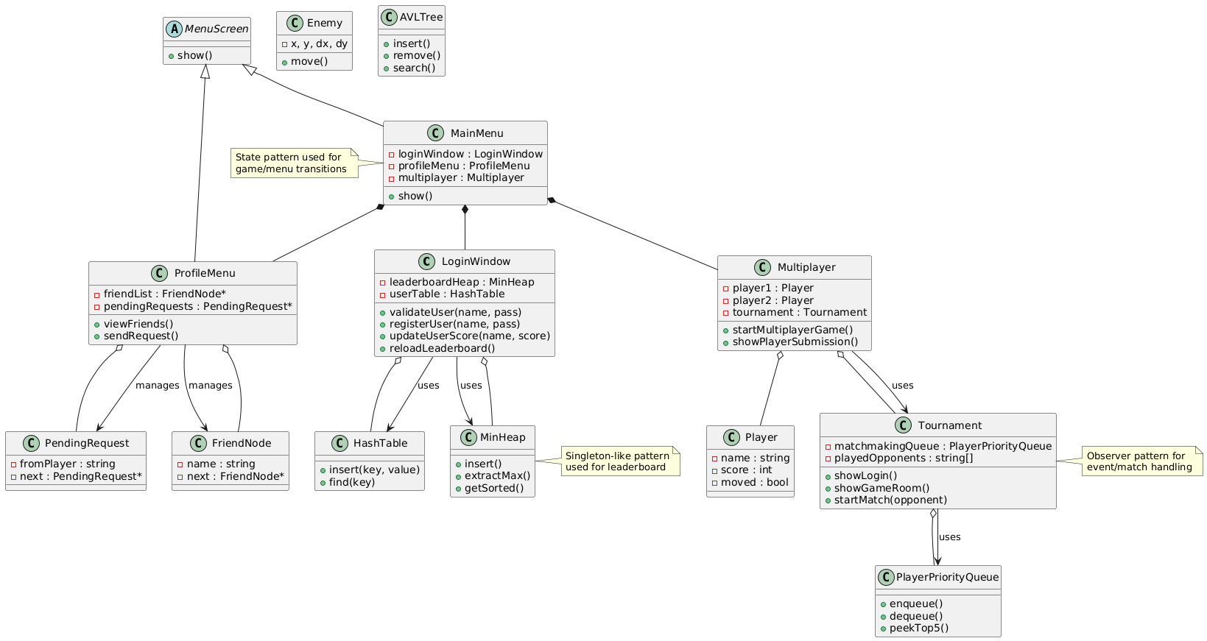

Game Snippets:
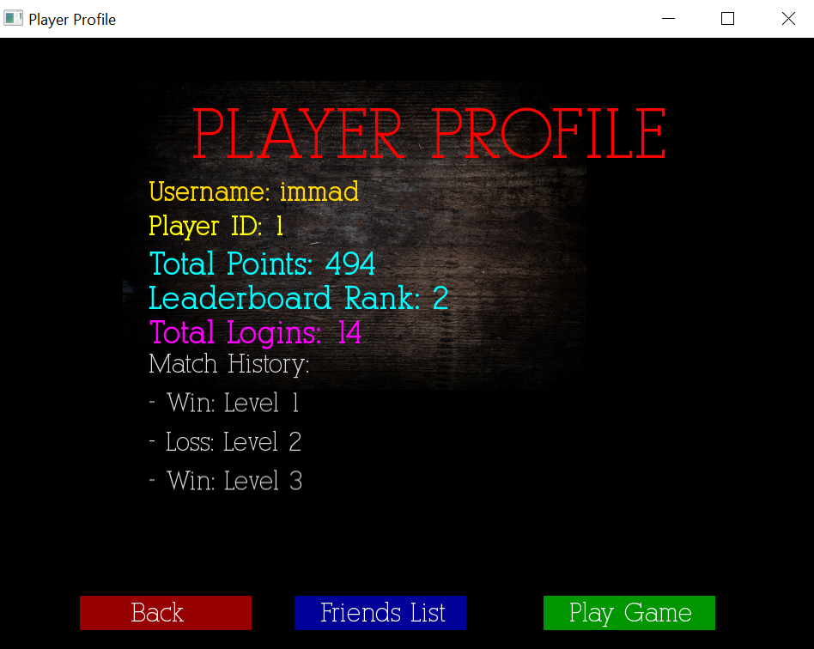
Player Inventory
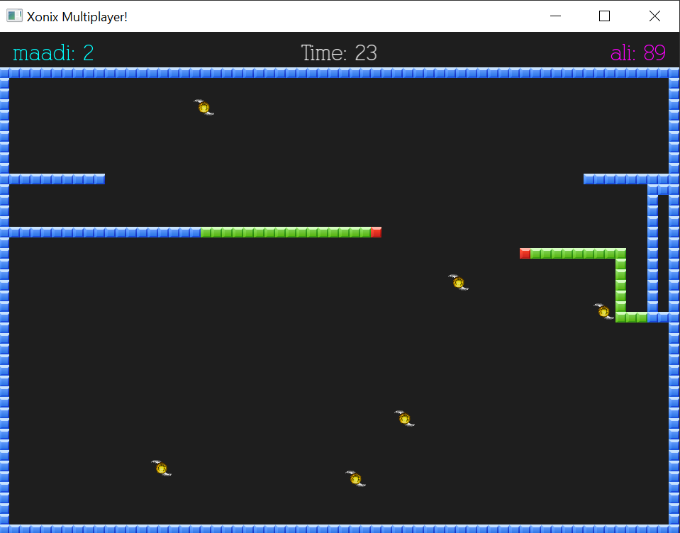
Multiplayer Mode

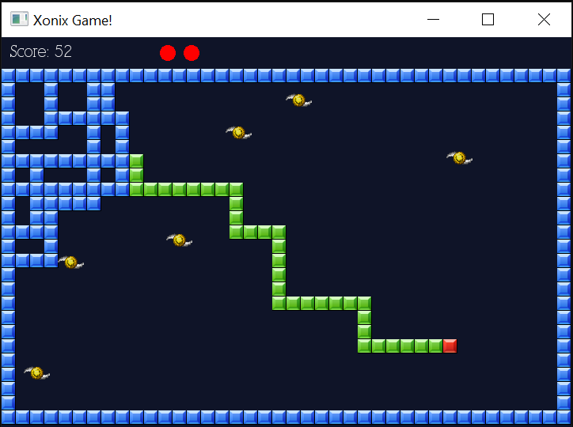
Single Player
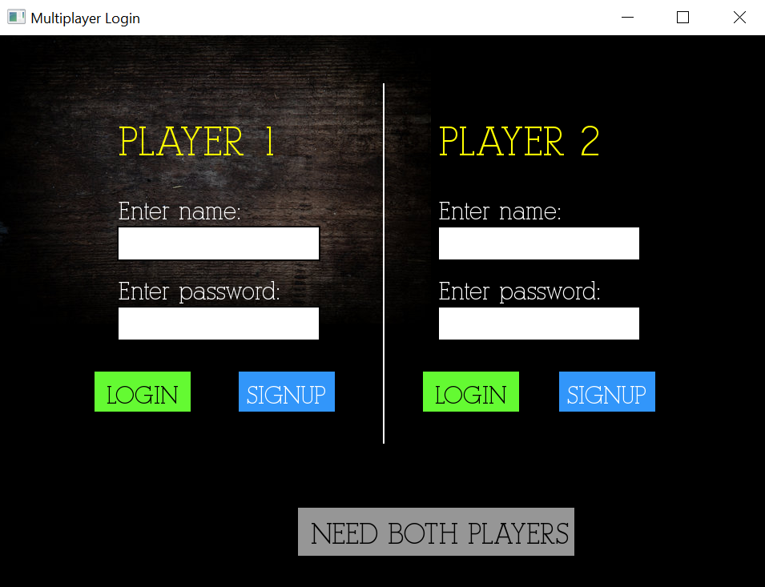

Multiplayer Login System

